CALL FOR PARTICIPANTS
Dear candidates,

A good(s) life. Chances and reality of a Civil Economy (AGL) is a Youth Exchange funded by the European Union in which you can have the chance to meet many young people from other European countries and to debate with them about the topic of environmentally sustainable entrepreneurship.

The Youth Exchange is organized by Legambiente, an Italian non-profit association born in 1980. Its mission is to make environmental culture the centre of a new kind of development and diffused well-being. Important values for the association are: the improvement of environmental quality; the fight against all forms of pollution; a wise use of natural resources; the creation of a more balanced relationship between human beings and the nature.

The idea that we would like to convey through this Youth Exchange is that a different way to make business is really possible and we would like to help the young people to see how this could be achievable and to stimulate an entrepreneurship in line with the environmental sustainability values.

AGL will take place in Galbiate, Lecco (LC), Italy, from August 23nd to August 31st, 2018.

The selected venue will be Ostello Parco Monte Barro, an eco-hostel led by Legambiente Lecco itself, which has already successfully hosted other similar Exchanges in recent years.
The Ostello will act as both the venue and a real-life example of the topic at hand, being a sustainable enterprise located in Monte Barro Regional Park.

The project will be joined by youngsters from Italy, France, Serbia and Czech Republic. Each national group will be composed of 6 people, for a total of 24 people joining AGL.
The Youth Exchange is open to participants from 21 to 30 years old. Some exceptions could be made for people from 18 to 21 years old, but they have to be discussed with the sending organization.

The program of AGL will include several activities, distributed throughout the nine days of the Exchange:
- Ice-breaking games and energizers at the beginning of each session (morning and afternoon), meant to stimulate group cohesiveness, especially during the first days;
- Exchange of ideas and good practices alongside participative discussions on sustainability (what it means, how it works, how it can be translated into reality, etc.);
- Short walks in the surrounding environment to show its beauty;
- Screenings of documentaries about sustainability;
- If feasible, a “sustainable treasure hunt” in the hostel;
- Interviews with young entrepeneurs from the Lecco area owning/working in sustainable businesses;
- Last but not least, the development of a business plan for a sustainable enterprise.

The language of the Youth Exchange will be English.

Concerning the financial aspects, the project covers the travel costs as follows:
- from Italy: no travel costs can be covered;
- from Serbia, France and Czech Republic: up to 275€ (way there and way back).

Accommodation and meals are fully covered by the project.

Info Pack with all the useful information will be sent to the selected participants.

For more information concerning the venue (Ostello Parco Monte Barro):
http://www.ostelloparcobarro.it/en

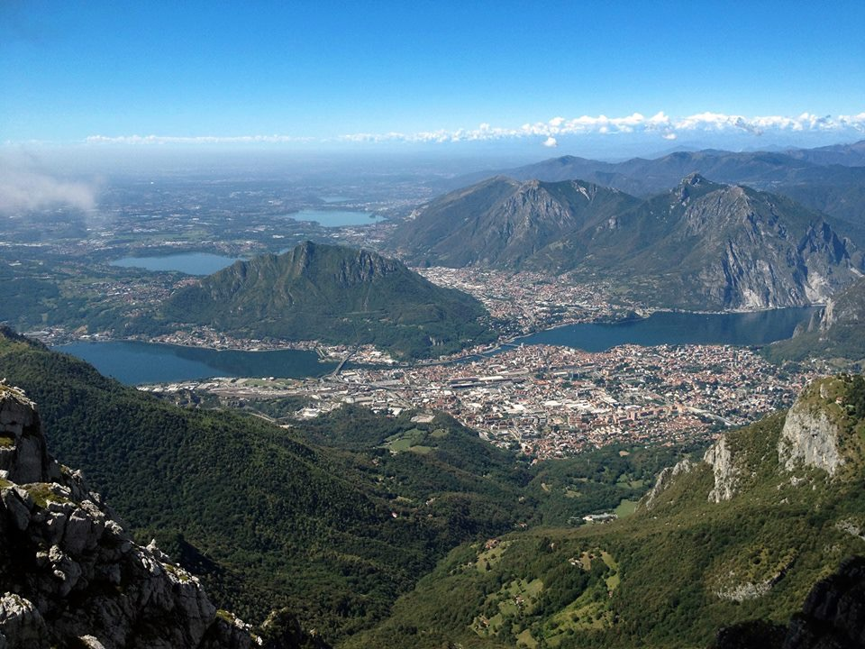
(A view from Ostello Parco Monte Barro :) )

